

**School of Computer Sciences & Engineering**

**Department of Computer Science & Application**

**Community Engagement Project**

**Synopsis**

**On**

# ‘PrioritizeMe’

# By

**Smaran P.Palashikar**

**230105011026**

Class & Semester:

SYBCA

4th Semester

Under the Guidance of

**Prof. Rohit Gupta**

**Academic Year: 2024-25 even Semester**

**PrioritizeMe**

**Abstract**

PrioritizeMe is more than just a to-do list app—it's a powerful tool for shaping your future. Designed to help users organize and manage their daily tasks, PrioritizeMe empowers you to set clear goals, break them down into manageable milestones, and track your progress over time. Whether you're focused on career growth, educational achievements, or personal development, PrioritizeMe serves as your strategic partner, guiding you toward your aspirations.

With an intuitive and interactive interface, customizable reminders, and smart prioritization features, PrioritizeMe enhances productivity and reduces stress. It allows you to create, categorize, and schedule tasks, set deadlines, and visually monitor progress in a user-friendly environment. Whether for personal or professional use, PrioritizeMe is built to help you stay on top of your commitments, plan your time effectively, and ultimately take control of your future.

PrioritizeMe: Your future, planned.

**Introduction**

In today’s fast-paced world, staying organized and managing time effectively can be a real challenge. From work deadlines to personal commitments, the constant juggling act can lead to stress and burnout. That's where PrioritizeMe comes in, offering a revolutionary solution to help you organize, manage, and execute your daily tasks with ease.

PrioritizeMe is a dynamic, user-friendly task management app designed to simplify how you approach your daily to-do list. With its intuitive interface and robust set of features, PrioritizeMe helps users prioritize tasks, set deadlines, and stay focused on what matters most. Whether you're balancing work projects, personal errands, or long-term goals, PrioritizeMe provides the tools needed to keep you organized and in control of your time.

Going beyond traditional task management, PrioritizeMe offers smart reminders, customizable categories, progress tracking, and priority-based organization to ensure no task is forgotten. It lets you monitor your progress in real time, helping you stay motivated and on track toward achieving your goals.

With PrioritizeMe, you can eliminate the chaos of scattered tasks and regain control of your schedule. It helps reduce stress, boost productivity, and set you up for success, making each day more organized and fulfilling. Say goodbye to feeling overwhelmed and start planning for success—PrioritizeMe is the productivity partner you’ve been waiting for.

More than just a to-do list, PrioritizeMe is a comprehensive productivity tool tailored for the demands of modern life. With its sleek design, cross-platform functionality, and powerful task management features, PrioritizeMe is the perfect solution for anyone looking to organize their tasks, meet deadlines, and achieve their goals with ease.

**System Architecture**

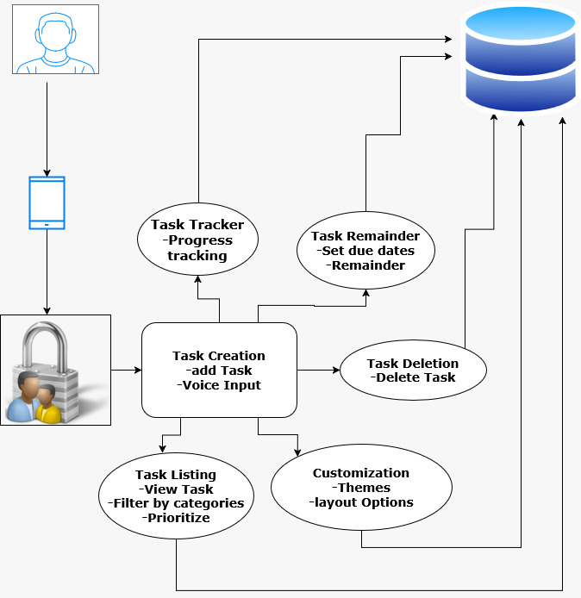

**Objectives**

1. Task Creation & Management: Users can easily create tasks, set deadlines, assign priorities, and add notes, with options to sort and filter tasks based on urgency or category.
2. Task Tracking & Completion: The app tracks task progress with visual indicators, allowing users to mark tasks as complete and monitor their status with percentage completion and progress bars.
3. Voice Input & Prioritization: Users can add and manage tasks using voice commands, prioritize tasks by urgency, and break down larger tasks into manageable steps.
4. Reminders & Customization: Automatic reminders ensure timely completion of tasks, while the app offers customizable themes, notification settings, and layout for a personalized experience.
5. Categories & Clutter-Free Management: Tasks can be organized into customizable categories, and the app provides easy task deletion and a clean interface for focused task management.

**Hardware & Software requirements**

Hardware Requirements:

i) Processor : Intel core i3

ii) RAM : Min. 2 GB

iii) HDD : 512 GB

Software Requirements:

i) Internet Connection

ii) Windows 10

iii) Python

-speechrecognization

-kivymd

**Conclusion**

In summary, the PrioritizeMe app is a transformative solution for task management, designed to empower users with a suite of features that streamline their daily activities. By facilitating task creation, listing, and viewing, the app allows users to efficiently organize their responsibilities and maintain a clear overview of their workload. The functionalities for task completion and deletion not only enhance user satisfaction but also promote a sense of achievement and focus on what truly matters.

The incorporation of voice input offers a modern, hands-free approach to task management, catering to users who prefer convenience and flexibility. Additionally, the ability to prioritize tasks and categorize them according to personal or professional needs ensures that users can effectively manage their time and energy, focusing on high-impact activities.

With the task tracker, users can monitor their progress visually, while automated reminders and due date notifications help keep them accountable and on schedule. The customization options further enhance the user experience, allowing individuals to tailor the app to their preferences and workflow.

Overall, the PrioritizeMe app is not just a task management tool; it is a comprehensive platform that fosters productivity, organization, and personal growth. As we move forward, our commitment to continuous improvement and user feedback will ensure that PrioritizeMe remains a valuable resource for anyone looking to optimize their task management and achieve their goals with confidence and ease.

**References**

1. <https://www.blackbox.ai/chat/SKtkm3s>
2. <https://app.diagrams.net/>
3. <https://youtu.be/dNNJZapp3M4?si=YhoY2KVG-iwQtfHH>
4. <https://youtu.be/sNi7JSobgKo?si=yExEdBHAxTneuxOg>
5. <https://www.w3schools.com/sql/>